Cost Management in Claude Code
What's in your hands, and what you can manage
Cost management in Claude Code comes down to a small set of choices you actually control: which model you select, how you manage context, and when you clear, compact, or resume. Everything else — caching, tool overhead, governance — builds on top of those three decisions. This guide walks through each lever in the order you'll meet it in a real session, then closes with a decision framework and FAQ you can come back to.

1. Model Selection
Anthropic offers a family of models running from cheapest to most capable. Because every token you send and receive is billed at that model's rate, picking the right model for the task in front of you is the single highest-leverage cost decision in Claude Code — bigger than any caching or context trick below.

Current model pricing (per million tokens)
Model | Input | Output | Typical use case
Claude Haiku 4.5 | $1.00 | $5.00 | High-volume, mechanical work: quick lookups, simple subagent tasks, background functionality
Claude Sonnet 5 (intro, thru Aug 31 2026) | $2.00 | $10.00 | Default daily-driver for most coding tasks. Standard $3/$15 applies from Sept 1, 2026
Claude Opus 5 / Opus 4.8 | $5.00 | $25.00 | Complex architectural decisions, multi-step reasoning, high-stakes review
Claude Fable 5 (Mythos-tier) | $10.00 | $50.00 | The hardest, longest-running, most autonomous tasks

Output tokens cost roughly 5x input tokens across the board, so verbose, chatty output is disproportionately expensive — a reason to also read the effort-level section below.

Doing this automatically in Claude Code
You don't have to manually switch models every time you change task type. Claude Code has built-in support for exactly this pattern:
opusplan — uses Opus while you're in plan mode (thinking through the approach), then automatically switches to Sonnet to execute it. This is the cleanest version of "spend on thinking, save on typing."
--advisor opus — keeps a cheaper model (e.g. Sonnet or Haiku) as the main driver, but lets it consult a stronger model at key decision points — before committing to an approach, on a recurring error, or before declaring a task done — instead of switching wholesale. The advisor's tokens are billed at the advisor's rate, but only for the calls it actually makes, so this usually costs less than running the stronger model for the whole session.
Per-subagent models — a subagent's frontmatter can pin model: haiku, so mechanical delegated work (like codebase search) always runs on the cheapest model regardless of what the main conversation is using.
Note: The /model picker shows live prices when talking directly to the Anthropic API. On Bedrock, Vertex, Foundry, or a gateway, your provider determines the actual bill, and the picker price is a label only.

REFERENCES — MODEL SELECTION
• Manage costs effectively — choose the right model
• Model configuration (aliases, opusplan, effort levels)
• Official Claude API pricing
• Escalate hard decisions with the advisor tool

2. Context Management
Every message you send resends your entire conversation so far — system prompt, project context, every prior turn, every tool result — plus your new message. Context management is the practice of deciding what stays in that resent payload, what gets removed or summarized, and what never gets added in the first place. That splits into two related but distinct goals: keeping the resent conversation small, and keeping it useful. Skills and subagents are the two main tools, and they pull in different directions on that split.

a) Skills
A skill is a SKILL.md file with instructions that Claude loads on demand. Unlike your CLAUDE.md file, which is read in full at the start of every session regardless of whether you need it that turn, a skill's full body only enters context when it's actually invoked — only its name and short description sit in context the rest of the time.
- Cost benefit: move detailed, occasional-use instructions (a deployment checklist, a database-migration procedure, API conventions) out of CLAUDE.md and into a skill. You stop paying for those tokens on every single turn of every session.
- A "codebase-overview" skill can hand Claude your architecture, key directories, and naming conventions in one shot, instead of Claude spending tokens rediscovering the same structure by reading files across several turns.
- Keep CLAUDE.md itself under roughly 200 lines of true essentials; push everything else into skills.

b) Subagents
A subagent runs in its own, separate context window with its own system prompt and tool access. When a task would flood your main conversation with search results, logs, or file contents you'll never reference again, delegating it to a subagent keeps that noise out of your main context — only the subagent's summary comes back.
- Use a subagent to isolate high-volume operations: running a full test suite, fetching long documentation, or grepping through large log files.
- Pin a subagent to a cheaper model (haiku) for mechanical delegated work, since it inherits the main model by default otherwise.
- Trade-off: a subagent starts with a completely fresh, cold context and its own cache, so its first call is never a cache hit. It also uses the 5-minute cache TTL even when your main session is on the 1-hour subscription TTL. For a short side-task this cost is trivial; for something that needs your session's full history, a fork (via /subtask) — which inherits everything and reuses the parent's cache — is usually cheaper than a fresh subagent.
REFERENCES — CONTEXT MANAGEMENT
• Explore the context window
• Extend Claude with skills
• Create custom subagents
• Manage costs — reduce token usage

3. Prompt Caching

What it is
Without caching, the API would reprocess your entire conversation history from scratch on every single turn. Prompt caching lets it reuse what it already processed and only do new work for what changed since the last request.

How it works
Claude Code orders each request so the parts that rarely change come first — system prompt, then project context (CLAUDE.md, auto memory), then the conversation itself. The API matches the start of your new request (the "prefix") against what it recently cached. The match is exact: a change anywhere in the prefix recomputes everything that comes after it. There's no per-file or per-segment caching — it's all-or-nothing for whatever changed.

Price
Cache operation | Multiplier vs. base input price | Duration
5-minute cache write | 1.25x | Cache valid 5 minutes
1-hour cache write | 2x | Cache valid 1 hour
Cache read (hit) | 0.1x | Same duration as the write

A cache hit costs about 10% of standard input price, so caching pays for itself after just one read on the 5-minute TTL, or two reads on the 1-hour TTL. On a Claude subscription, Claude Code requests the 1-hour TTL automatically at no extra cost to you; on an API key or third-party provider, it defaults to the cheaper 5-minute TTL unless you opt into the 1-hour one.

What breaks the cache vs. what doesn't
Invalidates the cache (slow, expensive turn follows) | Keeps the cache intact
Switching models (each model has its own cache) | Editing files Claude previously read
Connecting/disconnecting an MCP server mid-session | Editing CLAUDE.md mid-session (just doesn't apply until next /clear or /compact)
Denying an entire tool (bare tool name deny rule) | Changing output style or permission mode
Compacting the conversation (/compact) | Invoking skills and commands
Upgrading the Claude Code version | Running /recap or /rewind

This is why opusplan's plan-mode toggle, or any mid-task /model switch, quietly costs you a full uncached reprocessing of history — it can feel free until you notice the slower, pricier turn that follows.
REFERENCES — PROMPT CACHING
• How Claude Code uses prompt caching
• Prompt caching — Claude API reference

4. Output Token Control & Reasoning Effort Control
Extended thinking is on by default because it meaningfully improves complex planning and reasoning — but thinking tokens are billed as output tokens, at the ~5x output rate, so this is one of the fastest ways to overspend on simple tasks.

Effort levels
Level | When to use it
low | Short, scoped, latency-sensitive tasks that aren't intelligence-sensitive
medium | Cost-sensitive work that can trade off some intelligence
high | The default on almost every model — balances token spend and intelligence
xhigh | Deeper reasoning at higher spend
max | Hardest problems only — prone to overthinking and diminishing returns; test before adopting broadly

Set it with /effort, in the /model picker, with the --effort flag, or in a skill/subagent's frontmatter to scope it to just that workflow. Changing effort mid-session does not invalidate the prompt cache — unlike a model switch, it's free to adjust.
You can turn thinking off entirely (MAX_THINKING_TOKENS=0 or the /config toggle) for simple, repetitive tasks — except on Fable 5, which always thinks regardless of the setting.

Fast mode
Fast mode trades money for speed on Opus: it runs at roughly a 2x premium ($10/$50 per MTok on Opus 5 / Opus 4.8) in exchange for significantly lower latency. Reserve it for genuinely latency-critical work, after confirming Sonnet doesn't already meet your speed bar.
REFERENCES — OUTPUT TOKEN & EFFORT CONTROL
• Model configuration — adjust effort level
• Fast mode
• Manage costs — adjust extended thinking

5. Tool Use and MCP Costs
Every tool you give Claude access to has a token cost, even before it's called: the tool's name, description, and schema sit in your system prompt on every turn. Simply having tools available adds a small fixed overhead per request (roughly 300–600 tokens depending on the model and tool-choice mode), and each additional tool definition (bash, text editor, computer use, etc.) adds more on top.

MCP servers
MCP tool definitions are deferred by default ("MCP tool search"), so only tool names — not full schemas — enter context until Claude actually uses a specific tool. But the set of available tool names still has to stay stable for the cache to remain valid: an MCP server connecting or disconnecting mid-session — even automatically, like a stdio process exiting or an HTTP session expiring — invalidates your prompt cache the same way switching models does.

Reducing the overhead
- Prefer CLI tools where they exist. Tools like gh, aws, gcloud, and sentry-cli are more context-efficient than an equivalent MCP server, because they add no per-tool listing to your context at all.
- Run /mcp to see every configured server and disable ones you aren't actively using in this project.
- Scope an MCP server to a specific subagent's frontmatter instead of the main session, so its tool definitions never enter your main conversation's context.
REFERENCES — TOOL USE AND MCP COSTS
• Use MCP servers (tool search, scaling)
• Manage costs — reduce MCP server overhead
• Tool use pricing — Claude API reference

6. Observability
You can't manage what you can't see. Claude Code gives you three layers of visibility, from a quick in-session check to full organizational telemetry.
- /usage — shows the current session's token usage, cost, and model breakdown, plus (on Pro/Max/Team/Enterprise) what fraction of your plan limit skills, subagents, plugins, and individual MCP servers are consuming. It also flags when long context or cache misses account for 10%+ of recent usage.
- Console / Analytics API — API organizations get a live cost and usage dashboard in the Claude Console, plus the Claude Code Analytics API for per-user, per-day metrics.
- OpenTelemetry export — works on every setup (subscription, API, or cloud provider) and is the only option that streams per-user token and cost metrics into your own observability stack in near real time. This is what you want for cross-team dashboards or alerting.
A well-designed statusline (see Section 8) turns this from something you check occasionally into something you see continuously while you work.
REFERENCES — OBSERVABILITY
• Monitor usage (OpenTelemetry, metrics, events)
• Manage costs — track your costs
• Track team usage with analytics

7. Governance: Budgets & Limit Policy
Which levers you have depend on how your organization accesses Claude Code.
- Claude for Teams/Enterprise: usage draws from a per-seat allowance on a rolling 5-hour and weekly window. Turn on usage credits to let people continue past that allowance, then cap spend at the organization, group, or individual level.
- Claude Console (API): set workspace-level spend limits and view cost/usage reporting directly in the Console.
- Cloud providers (Bedrock, Vertex, Foundry): billing and budget controls live in your cloud provider's console; use OpenTelemetry or an LLM gateway for per-user attribution.

Rate limit recommendations by team size
Team size | TPM per user | RPM per user
1–5 users | 200k–300k | 5–7
5–20 users | 100k–150k | 2.5–3.5
20–50 users | 50k–75k | 1.25–1.75
50–100 users | 25k–35k | 0.62–0.87
100–500 users | 15k–20k | 0.37–0.47
500+ users | 10k–15k | 0.25–0.35

Per-user TPM allowance shrinks as the team grows, because fewer people tend to use Claude Code concurrently in larger organizations.

Policy controls beyond spend
- availableModels (with enforceAvailableModels) restricts which models a user can select at all — a harder guarantee than a spend limit.
- Organization default model sets what a fresh session starts on org-wide, without blocking a user from switching.
- Organization effort limits cap the maximum /effort level per model per role — useful if xhigh/max usage is driving unplanned spend.
REFERENCES — GOVERNANCE, BUDGETS & LIMITS
• Manage costs for your organization
• Restrict model selection
• Organization effort limits

8. Your Statusline + a Handoff Workflow
A statusline turns cost and context awareness into something ambient instead of something you have to remember to check. Claude Code feeds your script live JSON on every update — model, context usage, cost, cache stats, rate limits — and you decide what to surface and how to color it.

A recommended statusline
Claude Code's built-in fields make it straightforward to build the statusline described in the original brief: model, prompt count proxy, a context-usage bar, cost per prompt, cache-hit signal, and total cost — with threshold-based coloring.
Field | Source
Model | model.display_name
Context bar / % | context_window.used_percentage (color it: green < 60%, yellow 60–80%, red > 80%)
Cost so far | cost.total_cost_usd
Cache hit signal | context_window.current_usage.cache_read_input_tokens vs. cache_creation_input_tokens — a high read-to-write ratio means caching is working
5h / 7d rate-limit burn | rate_limits.five_hour.used_percentage / rate_limits.seven_day.used_percentage (Pro/Max only)

Two refinements worth making to the brief as drafted: cache your git and other slow shell calls (keyed on session_id, refreshed every few seconds) since your script reruns on nearly every turn; and add a refreshInterval only if you also want the line to update while the session sits idle waiting on background subagents — otherwise the event-driven updates (new message, /compact, permission-mode change, vim toggle) are enough and cost nothing extra, since the statusline runs locally and never touches the API.

A handoff.md workflow
There's no built-in Anthropic feature literally named "handoff.md" — the pattern you're describing is best built as a project skill, and it's a genuinely good idea for cost control. Here's a clean way to build it:
- Create a skill at .claude/skills/handoff/SKILL.md, invoked as /handoff, that writes a compact structured summary — current goal, key decisions, open threads, next step — to a HANDOFF.md file in the repo.
- Add a PreCompact hook that runs the same summarization before an auto-compaction fires, so a handoff exists even if you didn't trigger one manually.
- A SessionStart hook can check for a recent HANDOFF.md and offer to load it as the first message of a new session — this is your "/handoff latest" behavior.

Handoff vs. resume: the cost logic
This is really a caching question. /resume reloads the entire prior conversation. If you're within the cache TTL (1 hour on a subscription, 5 minutes on API/third-party by default) that reload is a cache hit and cheap. Past the TTL — or after a Claude Code version upgrade, which always invalidates the cache — resuming a long session reprocesses the whole history uncached, and that first turn back can be the single most expensive request in the session. A short, hand-written HANDOFF.md, by contrast, is a small fresh document: reloading it costs a few hundred tokens regardless of how long you've been away, at the price of losing the fine-grained history a full resume keeps.
REFERENCES — STATUSLINE & HANDOFF WORKFLOW
• Customize your status line
• Hooks (PreCompact, SessionStart)
• Work with sessions (resume, context)
• Extend Claude with skills

9. Quick Decision Framework
Situation | Do this
Switching to a completely unrelated task | /clear — stale context wastes tokens on every later message
Same task, context is large but still relevant | /compact, ideally with custom focus instructions
Went down the wrong path and want to undo | /rewind — truncates to an already-cached earlier point, cheaper than /compact
Stepping away for minutes, same task | Just come back — likely still within the cache TTL
Stepping away for hours/days, or ending for the day | Write a handoff, or accept that /resume's first turn back will be a large, uncached request
Verbose/high-volume sub-task (tests, logs, research) | Delegate to a subagent
Reusable checklist or domain knowledge | Turn it into a skill
One hard architectural decision, then routine execution | opusplan, or the advisor tool with a cheaper main model

Decision framework reference sketch
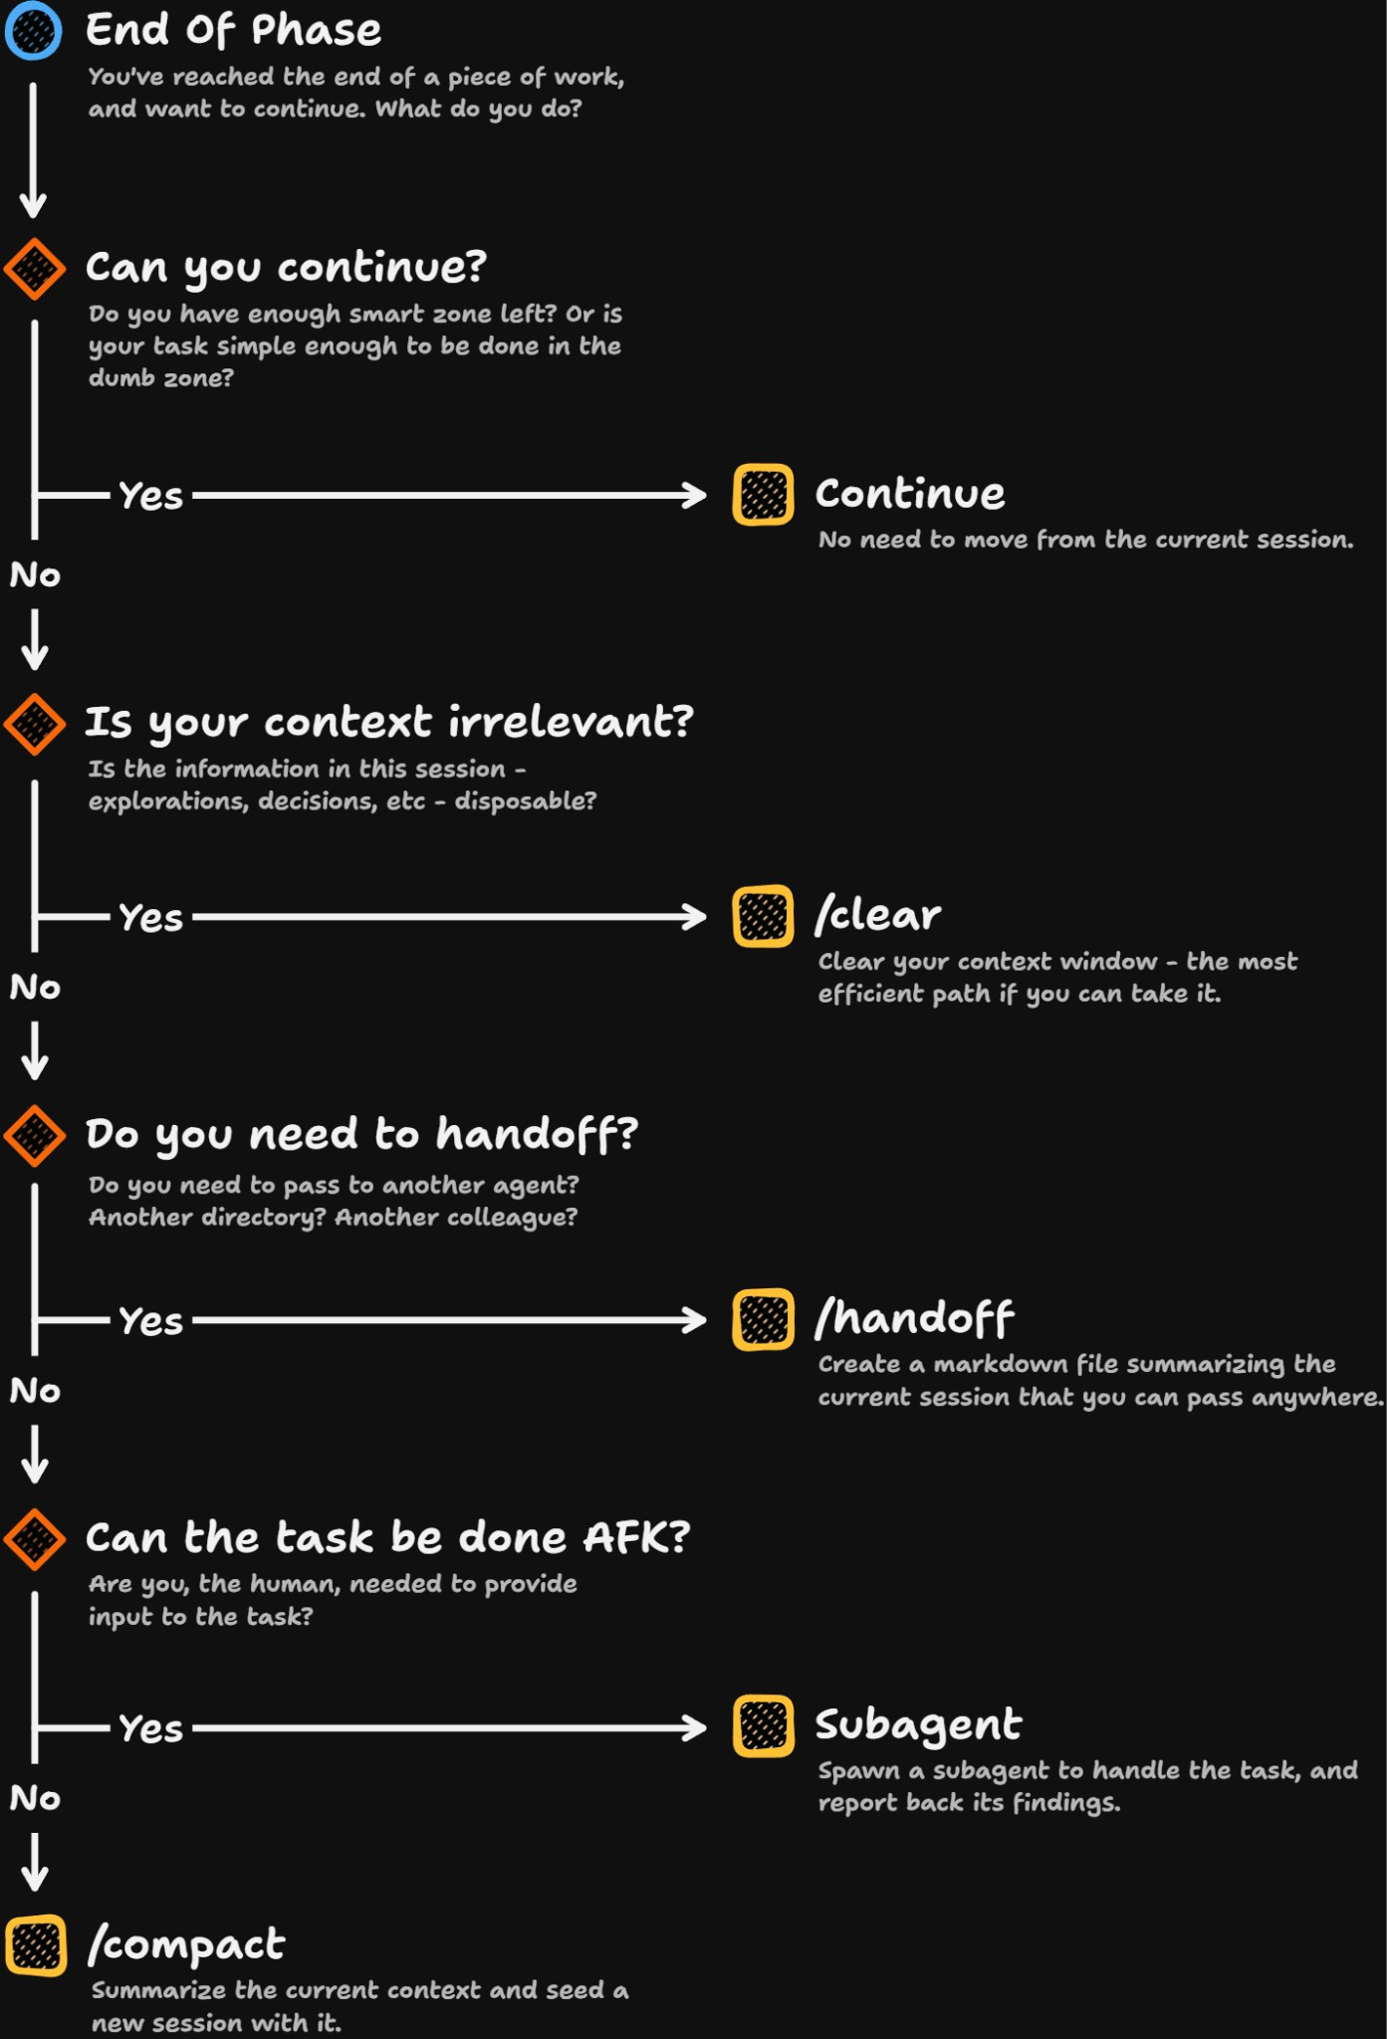
REFERENCES — QUICK DECISION FRAMEWORK
• Manage costs effectively
• Prompt caching — cache lifetime

FAQ

1. Should I /resume a previous session or write a handoff for the next one (accounting for prompt caching)?
If you'll be back within the cache TTL (about an hour on a subscription, five minutes on API/third-party), /resume is simple and the reload is a cache hit. If you're picking it up the next day, or the session is very long, a handoff is usually cheaper — /resume's first turn back reprocesses the entire history with no cache hits at all.

2. When should I /clear vs. /compact?
/clear when you're switching to genuinely unrelated work — there's nothing worth summarizing. /compact when you want to keep working on the same task but the conversation has grown large; give it focus instructions (e.g. /compact focus on code changes and test output) so it keeps what you actually need.

3. Is prompt caching still useful if I start work the next day — should that use handoff.md or resume?
A gap of a day is almost always past any cache TTL, so caching won't help a plain /resume — you'll pay for a full, uncached reprocessing of the whole history. A handoff is the cheaper option here: it's a small, fresh document rather than a multi-hour-old conversation.

4. Should I use a subagent or just stay in-context, given prompt caching exists?
Caching makes staying in-context cheaper than it used to be, but it doesn't shrink the context itself — a subagent still keeps verbose output (test logs, research, file dumps) from ever entering your main conversation, which caching can't undo once it's there. Use a subagent for anything you don't need to reference again; stay in-context for iterative, back-and-forth work.

5. Does a handoff resume correctly inside an already-compacted session?
Yes — a handoff file is just plain content you load as the first message of a fresh session, so it doesn't care whether the previous session had been compacted, rewound, or was pristine. What it can't do is restore fine-grained history; it only restores whatever you chose to write down.

6. When exactly does a handoff.md-style workflow pay off?
It pays off most when you're resuming similar, bounded work after a longer gap — the next morning, after a multi-hour break, or when picking a task back up after several other sessions in between. It pays off least for quick same-hour continuations, where a plain /resume is already a cheap cache hit and a handoff would just lose detail for no savings.

7. Does switching models mid-session cost anything extra?
Yes. Each model has its own cache, so a /model switch — including the plan-mode toggle inside opusplan — means the very next request reads your entire history with zero cache hits, even though the content hasn't changed.

8. Does opusplan end up costing more than just running Sonnet the whole session?
Usually not, if your task genuinely benefits from Opus-level planning. You pay Opus rates only during plan mode, then drop to Sonnet rates for execution — cheaper than running Opus throughout, and more capable at the planning stage than running Sonnet throughout.

9. Is the advisor tool cheaper than just switching to Opus for the whole session?
Typically yes. The advisor is only consulted at specific decision points rather than on every turn, so a fast main model plus an occasional stronger advisor call usually costs less in total than running the stronger model for every single message.

10. Do MCP servers cost tokens even when I'm not using their tools?
A small amount, yes — the tool's name still sits in your system prompt once MCP tool search is active, though full schemas are deferred until first use. Disable servers you aren't using for that project with /mcp, and prefer an equivalent CLI tool where one exists.

11. Does raising effort to xhigh or max always justify the extra cost?
No. high is the default because it already balances cost and capability well on almost every model. xhigh and especially max are prone to overthinking on tasks that don't need it — reserve them for genuinely hard problems and test before adopting broadly.

12. Are agent teams more expensive than subagents?
Yes, substantially — agent teams can use roughly 7x the tokens of a standard session when teammates run in plan mode, because each teammate is a fully separate Claude instance with its own context window. Keep teams small and shut teammates down as soon as their work is done.

13. Does an idle session cost anything while I'm not typing?
A small amount. Background conversation summarization for /resume and occasional status checks (like /usage) can add a few cents per session even with no active interaction, plus anything a scheduled task or an active background subagent is doing on its own.

14. Does the 1M-token context window cost more per token?
No — on current models (Sonnet 5, Fable 5, Opus 4.6 and later), the 1M context window uses standard per-token pricing with no premium beyond 200K tokens. A 900K-token request is billed at the same rate as a 9K-token one.

15. How do I see exactly where my tokens are going in a session?
Run /usage for a live breakdown by model, including a percentage split across skills, subagents, plugins, and individual MCP servers on paid plans. For anything beyond a single session, OpenTelemetry export gives you per-user, per-session cost and token metrics in your own dashboard.
REFERENCES — FAQ
• Manage costs effectively (full reference)
• How Claude Code uses prompt caching
• Create custom subagents
• Model configuration

